April 2026

Celebrations
Wednesday


Sunday Monday Tuesday
7
Umesh
3
10
Umesh
2
1
4
Thursday
Friday Saturday





9
11
6
8
15 Umesh
23
24
14
16
18
17
30
29
25
12
19
26

5
13
20
21
27 Umesh
28
22

April 2026

Celebrations
Tuesday
Wednesday

Sunday Monday
1
Friday Saturday
3
Thursday
2
4





11
5


6
7
Umesh
8
9
10
Umesh

April 2026

Celebrations

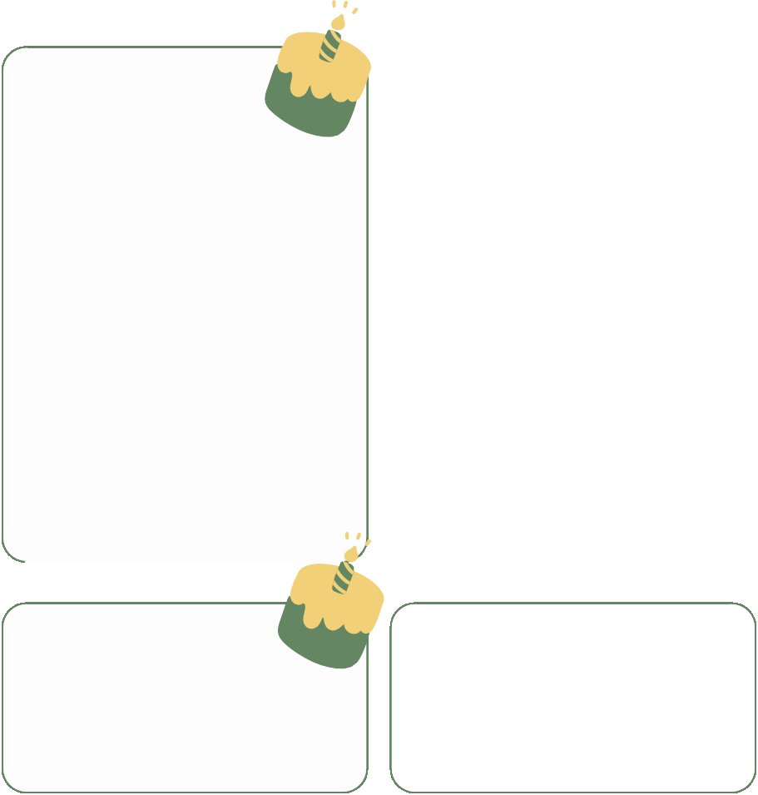
Sunday Monday Tuesday
14
15
16
Umesh
22
23
18
13
17
Wednesday Thursday
Friday Saturday





21
24
25
19

12

20

April 2026

Celebrations

Sunday Monday Tuesday
Wednesday Thursday
Friday Saturday






26

27 Umesh
28
29
30

